Math Circles Workshops for Elementary School Students at UBC
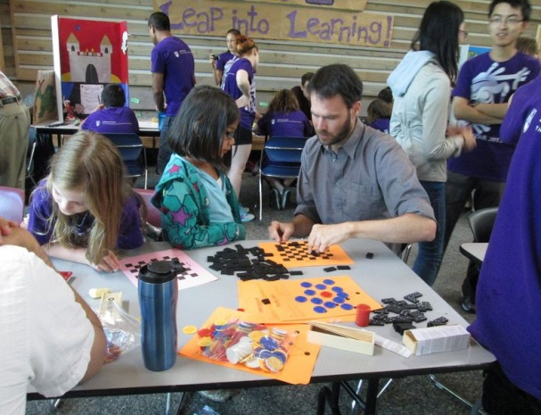
Students of grades 4 to 7 are invited to challenge and develop their thinking and creativity skills at the Math Circle Workshops.

This is an enrichment program
for students organized by the faculty members of the Department of Mathematics at the University of
British Columbia and the Pacific
Institute for the Mathematical Sciences.
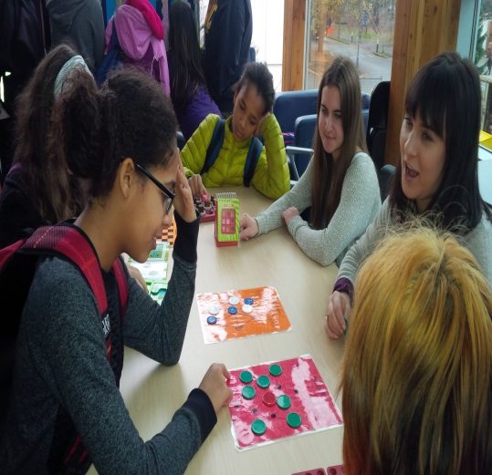
The goal of these workshops is to convey to students the importance of mathematics in the real world as well as how much fun mathematics can be. We want to get the students excited about mathematics and to give them a setting that encourages them to become passionate about this subject.

The Math Circle Workshops sessions take place on Monday evenings from 4:30 to 6:00 pm, at the Earth Science Building fourth floor room 4133.
- There is a $5 fee per child (parents are free).
- Parents are welcomed and encouraged to stay.
- To book any of these days or for more information send an email to melania@pims.math.ca.
- Drop-Ins are welcome if seating is available.

Schedule Winter/Spring Room 4133 (fourth floor)
January 28, February 11 & 25 , March 11 and April 1 & 15

