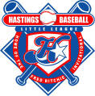
IT’S TIME TO REGISTER
FOR BASEBALL

Online Registration for the 2017 baseball
season at Hastings Community Little League
is now open at www.hcll.ca. All boys and
girls aged 4 to 12 years old and who live
or attend a school within the league boundaries
are eligible.

